Please delete this guidance before providing the offer of employment.

The only editing which should be done to this template is where there is red text or there is no code of conduct to provide. There should be no removal of subheaded paragraphs.

To ensure you are always using the most up-to-date letter of offer, we recommend downloading the template from the Resource Centre each time you make an offer instead of reusing letters you have used for previous appointments.

Fixed Term Employment Agreements

- In general, the law requires that all positions are permanent unless there is a genuine reason based on reasonable grounds for it to be otherwise.
- Generally, funding and roll fluctuations are not genuine reasons for using a fixed term employment agreement. If you are considering a fixed term for either of these reasons, please contact GovHub for further advice.
- The law around the use of fixed terms is strict, and Courts have often ruled in favour of employees who claim that they are permanent employees, despite being employed on an FTEA. You should read and be familiar with the content of the Fixed Term Employment Agreements article in the GovHub Resource Centre.
- Please do not use any of your previous letters of offer for fixed term employment as a template for new offers. There is a full suite of revised fixed term and acting-up resources in the Resource Centre.
Failure to provide a genuine reason based on reasonable grounds in writing could result in a legal challenge and compromise your insurance cover.

Safety Checking

You cannot offer employment until all safety checks under the Children’s Act 2014 have been completed.

Before this letter of offer is used to offer employment to the appointee, the following must be completed:
- Identity confirmation s5 Children’s (Requirements for Safety Checks of Children’s Workers) Regulations 2015
- Other information s7 Children’s (Requirements for Safety Checks of Children’s Workers) Regulations 2015: Interview, reference checks, etc.
- Police vetting/Information about previous criminal convictions (if any) s6 Children’s (Requirements for Safety Checks of Children’s Workers) Regulations 2015
- Risk assessment s8 Children’s (Requirements for Safety Checks of Children’s Workers) Regulations 2015

For advice on safety checking and police vetting results please contact GovHub on 0800 782 435 (Option 2).
Note: If the appointee holds a current practising certificate from the Teaching Council, police vetting by the employer is not mandatory. All other aspects of safety checking must still be applied.

Hours of work for part-time staff
- Clause 3.5 of the Community Education Collective Agreement requires that the hours of work specified in this letter of offer not only reflect the time spent on core tutoring duties during usual days at work, but also factor in commonly known and expected additional events and requirements throughout the year such as lesson planning, preparation of resources, administration, meetings, reporting, exam preparation and student activities.
- Any subsequent agreed changes to hours of work need to be recorded in writing.
Determining pay grade and step on appointment – Level One and Three Non-teaching Coordinators and Coordinator Assistants
Employees need to be placed on the appropriate remuneration grade and step as provided for in Part 3 of the Community Education Collective Agreement:
- Before advertising, determine the job description for the role.
  - For non-teaching coordinators, also identify, with reference to the job description, which of the three levels the role will sit in based on the definitions provided in Part 2 of the CECA. If it is identified that the role would be a level two non-teaching coordinator, see the section below titled Determining pay rate – Level Two Non-teaching Coordinator.
- With the job description, identify the skills/demands/responsibilities that are required of an employee as they carry out the role (excluding skills/demands/responsibilities that are one-offs or isolated events).
- Use the identified skills/demands/responsibilities to find the appropriate grade for the role (between 2 and 4 inclusive for coordinator assistants and level one non-teaching coordinators, and 5 and 6 inclusive for level three non-teaching coordinators) as set out in clause 3.6.1 of the collective agreement.
  - If the identified skills/demands/responsibilities of the employee do not fit solely within one grade, use the highest grade that contains work done by the employee.
- Subsequently, when making the appointment, using the identified grade, determine the appropriate step within the grade (represented by a number in the table in clause 3.4.3 for level one and level three teaching coordinators or clause 3.5 for coordinator assistants) to start the employee on based on the role and their previous experience. The factors to consider are:
  - Previous relevant paid and unpaid work experience
  - The particular skills and qualifications held by the employee
  - Where an employee has had a break of employment (including between employers) of less than 12 months and
    - was employed in an administration role covered by the Administration Support Staff Pay Equity Claim Settlement, and
    - where the skills / demands / responsibilities of the new role is within the same Work Matrix Grade as the previous role,
the starting step should be at least the step they last held.

Determining pay rate – Level Two Non-teaching Coordinator
- As the pay rate for level two non-teaching coordinators was higher than the pay rate at the top of step 4 under the pay equity settlement, employees are appointed at the rate specified in clause 3.4.3.
- If circumstances warrant it, a school can salary load at a rate higher than that specified in clause 3.4.3. It is important to clarify in writing with the employee whether this loading will exist only until the collective agreement rate reaches their salary loading rate, or whether there is agreement for some other arrangement.
Inclusive or exclusive of annual leave
- ‘Exclusive’ annual leave applies to term-time only employees, or employees who work some weeks outside of term-time, but less than 51 weeks per annum.

  - Holiday pay is paid out in a lump sum at the end of the year.

- ‘Inclusive’ annual leave applies to 52-week-a-year employees

  - Employees accrue an annual leave entitlement each fortnight. This currently starts at 20 days - the employee books this leave (at an agreed time i.e. the school holidays) and this is deducted from their leave balance. Remaining annual leave can be rolled over into the next years’ entitlement.
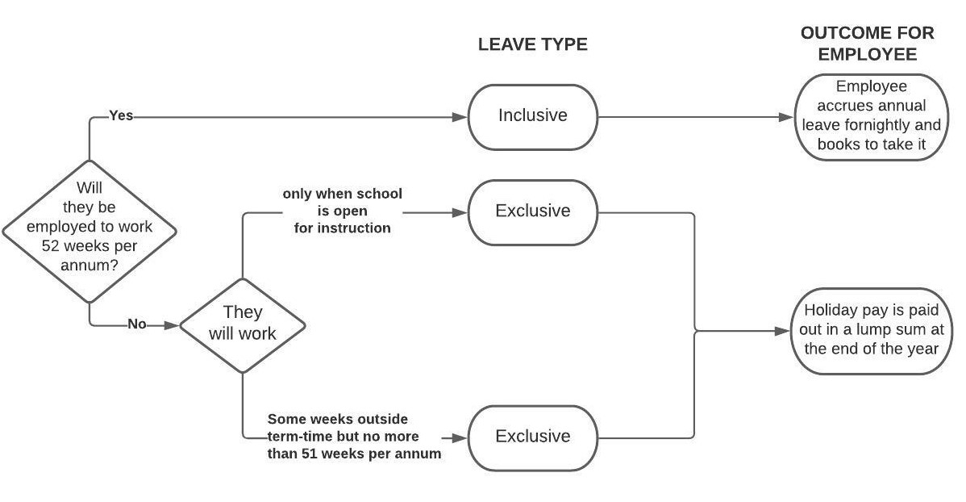
Union Matters
Employees are automatically employed under the terms and conditions of the Community Education Collective Agreement for the first 30 days of their employment.
If the employee indicates they are not a union member, the school needs to provide them with the following form and accompanying notice within ten days of them starting work:
- Form for new employees to indicate if they intend to join a union
- Accompanying notice
Further guidance on what to do once the employee has been provided the form, and what to do if the employee ultimately decides not to join a union, is available on the Resource Centre here.

Privacy, documentation signing and GovHub support

- The information obtained as part of the recruitment process and contained in the letter of offer is personal information and needs to be handled in a way consistent with the school’s privacy policy and the Privacy Act 2020.
  - Further advice and information on recruiting is available in our recruitment section in the GovHub Resource Centre.
- The offer of employment can only be made and signed by a person with the delegated authority to do so e.g., Presiding Member or Principal.
- You are welcome to send a final draft to the GovHub Advisory and Support Centre for review: eradvice@tewhakaroputanga.org.nz. Please allow at least 48 hours for our team to review and respond.

Please delete this guidance before providing the offer of employment.

Click or tap to enter a date.

[Employee]
[Address]

Tēnā koe [name]

Offer of Employment: Choose an item. fixed term part-time position to cover a Flexible Working Arrangement

The board of [school name] is pleased to offer you a fixed term part-time Choose an item. position at [school name] commencing on Click or tap to enter a date. and ending on Click or tap to enter a date..

This offer supersedes any previous negotiations, communications and commitments whether written or oral.

If you accept this position, please note that it is for a fixed term.

The reason for your employment being for a fixed term and not permanent is that you will be covering for an existing staff member who has a temporary change in working arrangements. This position will cease when the temporary flexible working arrangement expires on Click or tap to enter a date..

Position Details

A job description for this role is attached.

Your hours will be [insert hours per day and days per week] [include if working more than four hours a day: inclusive of a [30 minute] unpaid lunch break.] Any variation to these will be advised in accordance with the relevant provisions of the Community Education Collective Agreement (“the CA”) and recorded in writing.

Your remuneration on appointment will be based on the provisions of the CA that apply to your position. You will be appointed on [grade and step] and will be paid [insert hourly rate] per hour.

Administration Support Staff Pay Equity Claim Settlement

The work you are being offered is the same, or substantially similar to, work which is covered by a pay equity claim settlement under the Equal Pay Act 1972, namely the Administration Support Staff Pay Equity Claim.

You are therefore offered employment based on the same remuneration and other terms and conditions of employment included in the Administration Support Staff Pay Equity Claim settlement. The remuneration and other terms and conditions of employment are included in the CA.

If you accept this offer of employment, which includes the benefit of the Administration Support Staff Pay Equity Claim settlement, it will have the effect of barring you from raising your own claim in relation to pay equity in accordance with sections 2B and 13E(6) of the Equal Pay Act 1972.

Terms and Conditions of Employment

For the first 30 days of your employment, you will be covered by the terms and conditions of the CA.

A copy of the CA is available at https://www.education.govt.nz/school/people-and-employment/employment-agreements/collective-agreements/community-education-collective-agreement.

The CA covers the work that you will undertake and applies to employees who are or become members of PPTA Te Wehengarua.

If you are already a member of PPTA Te Wehengarua, the CA applies to you directly from the date of appointment.

If you are not already a member of PPTA Te Wehengarua you have the option of joining the union and being directly covered by the terms and conditions of the CA. If you wish to join the union, you should contact PPTA Te Wehengarua. Joining this or any other union is your choice. If you do choose to join the union, the CA will apply directly to you as long as you remain a union member.

After the 30-day period, if you have not joined PPTA Te Wehengarua, you will be on an individual employment agreement (“IEA”). The IEA will continue to reflect the terms and conditions of the CA. We will provide you with the IEA, along with information on dealing with employment relationship problems.

Notice Period

Unless mutually agreed to otherwise, if you wish to end the fixed term at an earlier date, one month’s notice or, where less than one month of the fixed term remains, the balance of the fixed term is required. As per clause 7.1.1 of the CA, the board of [school name] can decide to pay you in lieu of working out your notice period.

Child Protection and Safety

The Education and Training Act 2020 and the Children’s Act 2014 apply to your position.

During your employment, you must immediately disclose to the school any charges that are laid against you and if you are convicted of any crime.

[remove this section if not applicable] Code of Conduct

Attached you will find a copy of the code of conduct which outlines the minimum standards of conduct and behaviour expected of you as the board’s employee. Please sign and return the acknowledgement of receipt of the code of conduct.

Retirement Saving

You will be automatically enrolled into KiwiSaver if you are between 18 - 64 years of age and employed for more than 28 days. If you are already in KiwiSaver your current options will continue. Further information, including options for opting out, is available on the following websites: www.ird.govt.nz/kiwisaver and www.edpay.govt.nz.

Confirmation

We encourage you to take the opportunity to seek independent advice on this offer of fixed term employment.

Please sign and return this offer of employment within five working days from the date of the offer.

We look forward to having you join our staff. If you have any queries, please do not hesitate to contact me.

Nāku noa, nā

[Name]
[Principal/Presiding Member]
[School name] Board

                - Acceptance

I accept the fixed term position of Choose an item. at [school name] on the basis of the offer made in this letter.

[delete if not relevant] I have attached the acknowledgement of receipt of the code of conduct.

I confirm I have had the opportunity to seek appropriate independent advice.

I am/am not a member of PPTA Te Wehengarua. (please circle as appropriate)

I would/would not (please circle as appropriate) like to receive information on the KiwiSaver Scheme.

Name __________________________

Signature _____________________________Date ____________________

