Please delete this guidance before providing the offer of employment.

Employees must receive a letter of offer letter to sign and return to the employer. The employer should then provide a copy to the employee. We advise using the following GovHub template.

The GovHub template meets the legal requirements. The only editing which should be made to this is where there is red coloured text or there is no code of conduct to provide. There should be no removal of paragraphs unless directed.

Safety Checking

You cannot offer employment until all safety checks under the Children’s Act 2014 have been completed.

Before this letter of offer is used to offer employment to the appointee, the following must be completed:
- Identity confirmation s5 Children’s (Requirements for Safety Checks of Children’s Workers) Regulations 2015
- Other information s7 Children’s (Requirements for Safety Checks of Children’s Workers) Regulations 2015: Interview, reference checks, etc.
- Police vetting/Information about previous criminal convictions (if any) s6 Children’s (Requirements for Safety Checks of Children’s Workers) Regulations 2015
- Risk assessment s8 Children’s (Requirements for Safety Checks of Children’s Workers) Regulations 2015

For advice on safety checking and police vetting results please contact GovHub on 0800 782 435 (Option 2).
Note: If the appointee holds a current practising certificate from the Teaching Council, police vetting by the employer is not mandatory. All other aspects of safety checking must still be applied.

Managers
- Employees who manage staff (beyond general supervision) or operations who were appointed after 1 January 2008 should be employed using the Support Staff suite of appointment letters, as they are covered by the Support Staff in Schools’ Collective Agreement. An appropriate letter can be found on the Te Whakarōputanga website here.

Hours of work for part-time staff
- Hours of work specified in the letter of offer for part time staff should not only reflect the time spent on core duties during usual days at work, but also factor in commonly known and expected additional events and requirements throughout the year such as trips, meetings, professional development and school business.
- As far as possible, the regular work pattern for an employee needs to be arranged in a continuous block so they are not required to present to the school for work more than once per day.

Determining pay rate
  - The pay rates specified in the Collective Agreement are minimum rates. A school can pay higher than these rates.
Inclusive or exclusive of annual leave – explained

- ‘Exclusive’ annual leave applies to term-time only employees, or employees who work some weeks outside of term-time, but less than 51 weeks per annum.

  - Holiday pay is paid out in a lump sum at the end of the year.

- ‘Inclusive’ annual leave applies to 52-week-a-year employees.

  - Employees accrue an annual leave entitlement each fortnight. This currently starts at 20 days - the employee books this leave (at an agreed time i.e. the school holidays) and this is deducted from their leave balance. Remaining annual leave can be rolled over into the next years’ entitlement.
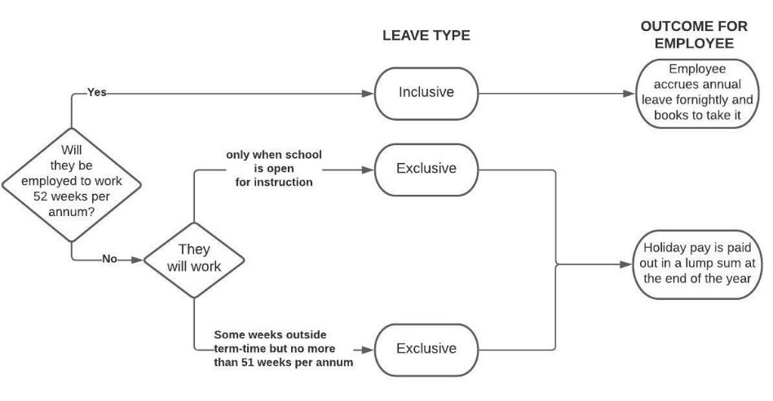

Privacy, documentation signing and GovHub support

- The information obtained as part of the recruitment process and contained in the letter of offer is personal information and needs to be handled in a way consistent with the school’s privacy policy and the Privacy Act 2020.

  - Further advice and information on recruiting is available in our recruitment section in the GovHub Resource Centre.
  - The offer of employment can only be made and signed by a person with the delegated authority to do so e.g. Presiding Member or Principal.

  - You are welcome to send a final draft to the Advisory and Support Centre for review: eradvice@tewhakaroputanga.org.nz. Please allow at least 48 hours for our team to review and respond.

Please delete this guidance before providing the offer of employment.
Click or tap to enter a date.

[Employee]
[Address]

Tēnā koe [Name],

Offer of Employment: [INSERT: Job title of canteen staff position] – Permanent, part-time

The board of [school name] is pleased to offer you appointment to the permanent, part-time position of [INSERT: Job title of canteen staff position] at [school name] commencing on Click or tap to enter a date.. A job description is attached.

This offer supersedes any previous negotiations, communications and commitments whether written or oral.

Your remuneration on appointment will be based on the provisions of the School Caretakers’, Cleaners’ and Canteen Staff Collective Agreement (“the CA”) that apply to your position. You will be paid [insert hourly rate] per hour on appointment.

Your hours of work will be [insert days of the week to be worked and working hours on those days][include if working more than four hours a day:, inclusive of a [30] minute unpaid lunch break.] These hours will be worked [term-time only or specify weeks to be worked per year], [inclusive or exclusive] of annual leave. Any variation to these will be advised in accordance with the relevant provisions of the CA.

[USE IF UNION MEMBER: Terms and Conditions of Employment

The terms and conditions of your employment are set out in the CA.

A copy of the CA is available at education.govt.nz/school/people-and-employment/employment-agreements/collective-agreements/school-caretakers-cleaners-and-canteen-staff-collective-agreement.]

[USE IF NOT A UNION MEMBER: Terms and Conditions of Employment

The terms and conditions of your employment are set by the attached promulgated Individual Employment Agreement for Caretakers, Cleaners and Canteen Staff (“the IEA”).

The IEA reflects the terms and conditions of the CA except for the modifications applicable to the IEA. A copy of the CA is available at education.govt.nz/school/people-and-employment/employment-agreements/collective-agreements/school-caretakers-cleaners-and-canteen-staff-collective-agreement.

As the CA covers the work that you will be doing, you can join E tū and become covered directly by the terms and conditions of the CA. If you wish to join the union, you should contact E tū at etu.nz/join. Joining this or any other union is your choice. If you do choose to join the union, the CA will apply directly to you as long as you remain a union member.

Consistent with section 62(3)(a)(c) of the Employment Relations Act 2000, with your agreement, we will notify E tū as soon as practicable that you have entered into an employment under an IEA with the board.]

Safety Checking

Please note that the Education and Training Act 2020 and the Children’s Act 2014 require police vetting and safety checks to take place when an employee is being appointed to a position in a school and every third year after their appointment. Your continued employment is therefore subject to ongoing satisfactory safety checks and police vetting.

During your employment, you must also immediately disclose to the school any charges that are laid against you and if you are convicted of any crime.

[remove if not applicable] Code of Conduct

Attached you will find a copy of the code of conduct which outlines the minimum standards of conduct and behaviour expected of you as the board’s employee. Please sign and return the acknowledgement of receipt of the code of conduct.

Retirement Saving

You will be automatically enrolled into KiwiSaver if you are between 18 - 64 years of age and employed for more than 28 days. If you are already in KiwiSaver your current options will continue. Further information, including options for opting out, is available on the following websites: ird.govt.nz/kiwisaver and edpay.govt.nz.

Confirmation

We encourage you to take the opportunity to seek independent advice on this offer of permanent employment.

[USE IF UNION MEMBER: Please sign and return this offer of employment within five working days.]

[USE IF NOT A UNION MEMBER: Please sign and return this offer of employment, along with the signed IEA, within five working days.]

We look forward to having you join our staff. If you have any queries, please do not hesitate to contact me.

Nāku noa, nā

[Name]
[Principal or Presiding Member]
[School name] Board

                - Acceptance

I accept the permanent position of [INSERT: Job title of canteen staff position] at [school name] on the basis of the offer made in this letter.

[delete if not relevant] I have attached the acknowledgement of receipt of the code of conduct.

[USE IF NOT A UNION MEMBER: I agree/do not agree to the board advising E tū that I have entered into an IEA with the board. (please circle as appropriate)]

I confirm I have had the opportunity to seek appropriate independent advice.

I would/would not (please circle as appropriate) like to receive information on the KiwiSaver Ss

Name __________________________

Signature _____________________________Date ____________________

